## DATA SCIENCE PROJECT USING EXCEL

## REPORT

(Project Semester January-April 2025)

**Electric Vehicle Dashboard Project**

### Submitted by:

### Prashant Baral

Project

Registration no: 12327401

Section: K23GW

Course Code: INT217

**Under the Guidance of** Baljinder kaur

(30453)

### Discipline of CSE/IT

**Lovely School of Computer Science Engineering Lovely Professional University, Phagwara**

**CERTIFICATE**

This is to certify that **Prashant Baral** bearing Registration no. **12327401** has completed **INT217** project titled, **“Electric vehicle Insights Dashboard project”** under my guidance and supervision. To the best of my knowledge, the present work is the result of his/her original development, effort and study.

### Baljinder Kaur Professor

**School of Computer Science Engineering**

Lovely Professional University Phagwara, Punjab.

Date: 13th April, 2025

**DECLARATION**

I, Prashant Baral, student of B.tech CSE under CSE/IT Discipline at, Lovely Professional University, Punjab, hereby declare that all the information furnished in this project report is based on my own intensive work and is genuine.

Date: 13th April, 2025 Signature

Registration No.12327401 Prashant

**Acknowledgment**

I would like to express my deepest gratitude to Prof. Baljinder Kaur, for her exceptional mentorship and unwavering support throughout the duration of this project. Her vast knowledge in the fields of data science and machine learning, combined with her patient and thoughtful guidance, played a pivotal role in the successful completion of this work. Her insightful suggestions and feedback consistently challenged me to think critically and improve the quality of my research. I am also grateful for the learning environment she fostered, which encouraged exploration and innovation.

In addition, I sincerely thank my peers and classmates for their helpful discussions, encouragement, and collaborative spirit during this project. Their input provided fresh perspectives that contributed meaningfully to the final outcome. I am also thankful to the open-source community for providing the tools, libraries, and resources that made the implementation of this project possible. Lastly, I acknowledge the dataset contributors for making this analysis feasible.

# Introduction

Electric vehicles (EVs) have emerged as a pivotal technology in the global effort to reduce carbon emissions and combat climate change. As transportation is one of the largest contributors to greenhouse gas emissions, transitioning to cleaner alternatives like EVs is essential for achieving sustainability goals. In recent years, the adoption of electric vehicles has gained significant momentum, fueled by advances in technology, a growing network of charging infrastructure, government incentives, and heightened environmental awareness.

The state of Washington, known for its progressive environmental policies, has witnessed substantial growth in EV adoption. As of recent years, the number of electric vehicles registered in the state has soared, with more consumers opting for cleaner alternatives to traditional internal combustion engine vehicles.

In this context, the **Electric Vehicle Insights Dashboard** was developed to provide a comprehensive and interactive analysis of EV adoption trends, distribution across utility providers, and compliance with clean fuel standards. By leveraging raw EV registration data, this dashboard transforms complex data into clear, actionable insights. It allows stakeholders—ranging from policymakers and utility providers to businesses and environmental groups—to make informed decisions regarding infrastructure planning, policy development, and future investments in green technologies.

This project utilizes data sourced from the **US Government's open data platform (data.gov)**, specifically from the "Electric Vehicle Population Data" dataset. The primary goal is to explore the EV adoption landscape in Washington State, focusing on aspects such as vehicle market share, adoption trends by model year, compliance with clean fuel programs, and regional utility provider distribution.

Key areas of focus include:

* Analyzing trends in EV adoption by model year.
* Assessing how EVs comply with clean energy standards (CAFV status).
* Visualizing the market share by vehicle make and average electric range by make.
* Evaluating EV adoption across various utility providers.

By presenting these insights in a user-friendly and interactive dashboard format, this project aims to contribute to the ongoing dialogue surrounding sustainable transportation and clean energy initiatives in the region.

# Source of Dataset:

The dataset used in this project was sourced from the **US Government's open data platform**, specifically from the **Electric Vehicle Population Data** dataset available on [data.gov](https://data.wa.gov/). This dataset contains detailed records of electric vehicle registrations across the state of Washington and provides valuable insights into the distribution of electric vehicles, their makes and models, and their compliance with clean energy standards.

Some Key fields included in the dataset are:

* **Vehicle Identification Number (VIN):** A unique identifier for each vehicle.
* **Make:** The manufacturer of the electric vehicle (e.g., Tesla, Nissan, Chevrolet).
* **Model Year:** The year the vehicle was manufactured.
* **CAFV Status:** Indicates whether the vehicle is eligible for clean alternative fuel vehicle (CAFV) programs.
* **Utility Provider:** The electric utility company associated with the vehicle's location.
* **Electric Range:** The estimated driving range of the vehicle on a full charge.

The raw dataset initially contained over 250,000 records, which were filtered and cleaned for the analysis.

# Dataset Preprocessing:

The **dataset preprocessing** phase involved several critical steps to ensure the data was clean, relevant, and ready for analysis. These steps were designed to improve data quality and remove any inconsistencies, while maintaining the integrity of the information. The following subsections highlight the specific steps involved in the preprocessing of the dataset:

#### **3.1 Data Volume Reduction**

* The original dataset contained **over 250,000 records**, representing EV registrations across multiple regions in Washington State. Given the volume of data and the need to focus on the most relevant entries, the dataset was reduced to **39,322 records**. This reduction was based on the inclusion of only vehicles that met certain criteria, ensuring the dataset remained focused on the key variables for analysis:
  + Vehicles registered in Washington State
  + EVs classified under the relevant Make (top 10), and model years (6 years)

#### **3.2 Column Cleanup**

Several columns were cleaned or removed to improve the dataset's usability:

* **Standardized Fields:** Columns such as **CAFV Status, Electric Utility**, and **Electric Range** were standardized to ensure consistent naming conventions and to remove any inconsistencies (e.g., multiple spellings or formats for the same utility provider).

#### **3.3 Text Optimization and Data type Fomatting**

During preprocessing, several **textual fields** contained long, inconsistent, or unstructured entries that hindered readability and analysis. To make the dataset more user-friendly and suitable for dashboard visualization, the following steps were taken:

**i. Text Cleanup and Standardization**

* **Long Text Entries:** Some columns like vehicle descriptions or utility provider names were excessively long or inconsistent. These were shortened and formatted to include only the essential identifiers, making the dashboard labels cleaner and more presentable.eg the CAFV status field is shortened to (eligible,non eligible , and eligibility unknown).Also, the names of electric utility providers were shortened.

**ii. Data Type Corrections** Many of the original columns in the dataset were in the default format type of **General**, which caused inconsistencies during analysis and pivot table creation. To resolve this, specific data types were assigned based on the nature of the column.

**iii. Formulas Used:**

**Different formulas were used for the purpose like if and substitute.**

**3.4 Missing Value Handling**

Handling missing values is critical to maintaining the integrity of the analysis:

* **CAFV Status:** Missing values in the **CAFV Status** column, which were found for a significant portion of vehicles, were left as "Eligibility Not Defined" to indicate the absence of data.
* **Electric Range:** Missing or incomplete **Electric Range** values were handled by:
  + Filling in **average values** based on similar makes. For this a sheet called average was made where we found unique makes and found respective average. Then replaced the missing the electric range values based on that.
* **Formulas used:**
* UNIQUE ('Filtered and Cleaned’! G2:G39323) to find unique make
* AVERAGEIF ('Filtered and Cleaned’! G$2: G$39323, A2, 'Filtered and Cleaned’! K$2:K$39323) to find average based on makes.
* IF (K2=0, VLOOKUP (G2, Average! $A$1:$B$11, 2, FALSE), K2) to fill the missing values.

#### **3.5 Sheet Organization**

To streamline the dashboard creation process, the data was organized into multiple sheets:

* **Raw Data: Contains the original data extracted from data.gov**
* **Filtered and Cleaned Data:** This sheet contained the final version of the dataset, with all irrelevant rows removed and data standardized for analysis.
* **Pivot Tables:** Pivot tables were created in a separate sheet to summarize the data and enable easy visualizations. This sheet included pivot tables for key metrics like EV adoption by model year, market share by make, and electric utility provider distribution.
* **Summary Statistics (Average):** A dedicated sheet was used to calculate and display average electric range per make .
* **Dashboard (Final Visualizations):** The final visualizations were displayed in a separate sheet, presenting the data in the form of charts, slicers, and buttons for interactivity.

#### **3.6 Hyperlink Integration**

For easy access and sharing, hyperlinks were integrated into the dashboard:

* A direct link was added to the ***data.gov*** platform, providing users access to the original dataset.
* A link to **Prashant’s LinkedIn profile** was included to enhance the professional presentation of the project, allowing stakeholders to connect and engage further.

# Analysis on Dataset:

#### **Objective 1: EV Adoption Trends by Model Year**

##### **i. General Description:**

This analysis aims to visualize the trend of electric vehicle adoption over time, based on the model year of the vehicles.

##### **ii. Specific Requirements:**

The analysis uses the model year to examine the rate at which electric vehicles have been adopted, identifying periods of rapid growth or slower adoption.

##### **iii. Analysis Results:**

* **Early Adoption:** EV adoption in 2000 and 2008 was minimal, with only 7 and 22 vehicles recorded respectively, likely due to early-stage experimental or fleet vehicles.
* **Rapid Growth (2013-2021):** From 2013 (4,096 vehicles) to 2021 (18,439 vehicles), the number of EVs surged, reflecting growing consumer demand, improved technology, and supportive government policies.
* **Anomalies in 2025:** There are 8,563 vehicles listed for 2025, suggesting the inclusion of pre-registered or projected vehicles, which could be a result of early model year entries or data anomalies.

##### **iv. Visualization:**

A line chart was created to show these trends over the years. The chart highlights significant growth between 2017 and 2021, showcasing the increasing adoption of electric vehicles.

#### **Objective 2: Compliance with Clean Energy Alternatives**

##### **i. General Description:**

This objective focuses on understanding how many EVs comply with the Clean Alternative Fuel Vehicle (CAFV) status.

##### **ii. Specific Requirements:**

Vehicles were categorized based on their CAFV status to assess how many EVs are eligible for clean energy programs.

##### **iii. Analysis Results:**

* **Majority of Vehicles Eligible:** A significant proportion of vehicles (12,459) were classified as "Eligible" for clean fuel programs, indicating strong alignment with clean energy goals.
* **High Number of Undefined Status:** A large portion of the vehicles (56%) had an "Eligibility Not Defined" status. This could be a result of newer vehicles not having updated CAFV statuses .
* **Not Eligible Vehicles:** About 11.7% (4,596 vehicles) were marked as “Not Eligible,” suggesting that older PHEVs or non-compliant vehicles were included in the dataset.

##### **iv. Visualization:**

A pie chart was used to visualize the distribution of CAFV statuses. This allowed users to quickly assess how many vehicles comply with clean energy standards, with slicers providing dynamic filtering by CAFV status.

#### **Objective 3: EV Market Share by Make**

##### **i. General Description:**

This objective analyzes the market share of electric vehicles by make, showing the distribution of EVs among different manufacturers.

##### **ii. Specific Requirements:**

The analysis categorizes vehicles by their make to understand the market dominance of top manufacturers.

##### **iii. Analysis Results:**

* **Tesla's Dominance:** Tesla leads the EV market in Washington State, accounting for 19,309 vehicles, a clear market leader with a significant share of the market.
* **Second-Tier Brands:** Chevrolet and Nissan follow with 4,667 and 3,755 vehicles, respectively. These brands play a strong role in the mid-market EV space.
* **Smaller Manufacturers:** Brands like Toyota, BMW, and Ford have between 2,100 and 2,500 vehicles, while Volkswagen, Volvo, Kia, and Audi round out the list with under 2,000 vehicles each.

##### **iv. Visualization:**

A **Tree Map** chart was used to represent market share. The size of each block in the map corresponds to the number of vehicles, making it easy to visually compare the dominance of each brand. Tesla’s block stands out as the largest, reflecting its market-leading position.

#### **Objective 4: Average Electric Range by Make**

##### **i. General Description:**

This analysis examines the average electric range for different EV makes, providing insights into how far each brand’s vehicles can travel on a single charge.

##### **ii. Specific Requirements:**

The dataset was used to calculate the average electric range for each make.

##### **iii. Analysis Results:**

* **Chevrolet Leads:** Chevrolet vehicles have the highest average electric range of 124 miles, which is notably higher than other brands.
* **Tesla and Nissan:** Tesla has a lower-than-expected average range of 48 miles, possibly reflecting a mix of older or shorter-range models. Nissan, with 78 miles, also performs well.
* **Shorter Ranges:** Brands like Ford, Toyota, and Volkswagen show shorter average ranges, potentially indicating smaller or more city-focused EVs.

##### **iv. Visualization:**

A **vertical bar chart** was created to show the comparison of average electric range across makes. The color scheme helps distinguish different brands easily, highlighting Chevrolet’s leading range.

#### **Objective 5: EV Adoption by Electric Utility Provider**

##### **i. General Description:**

This objective explores the adoption of EVs based on electric utility providers, showing how EVs are distributed across various utility regions.

##### **ii. Specific Requirements:**

The analysis categorizes vehicles by their electric utility provider to understand regional distribution.

##### **iii. Analysis Results:**

* **Puget Sound Energy Dominates:** The largest number of EVs is served by Puget Sound Energy, including Puget || Tacoma with 13,192 vehicles and Puget alone with 8,325 vehicles.
* **Other Utility Providers:** Utility providers like BPA || Clark PUD and BPA || Tacoma || Peninsula Light also serve substantial numbers of EVs, but their share is much smaller compared to Puget-based providers.
* **Smaller Providers:** Smaller utility providers such as PacifiCorp and BPA || Benton PUD have significantly fewer EVs.

##### **iv. Visualization:**

A **vertical bar chart** was used to display the number of EVs served by each utility provider, making it easy to compare their relative contributions. The data indicates that Puget-based utilities play a central role in EV adoption.

# Conclusion:

The **Electric Vehicle Insights Dashboard** provides an insightful, data-driven analysis of the electric vehicle (EV) landscape in Washington State. It leverages comprehensive EV registration data to highlight key trends and adoption patterns, offering valuable insights for utility providers, policymakers, and businesses alike. Based on the analysis conducted, the following key observations were made:

* **Surge in EV Adoption:** EV adoption has experienced a significant rise, especially since 2013. The increase in the number of vehicles, particularly from 2017 onward, suggests a growing acceptance of electric vehicles among Washington State residents. This growth is likely driven by several factors, including technological advancements in battery efficiency, government incentives, and a rising environmental consciousness among consumers. The rise of newer model years, particularly from 2021 to 2025, points toward a positive and continuous trend in EV adoption.
* **CAFV Compliance:** A significant portion of vehicles is eligible for clean fuel programs, with 31.7% of the EVs classified as "Eligible" for clean fuel incentives. However, a considerable portion (56%) of the vehicles still has an "Eligibility Not Defined" status. This suggests that there is missing data for newer models or incomplete administrative records. A smaller proportion of vehicles (11.7%) are categorized as "Not Eligible," indicating that these vehicles may not comply with current clean fuel standards, possibly due to older technologies like Plug-in Hybrid Electric Vehicles (PHEVs) or non-compliant vehicle models.
* **Market Share Insights:** The analysis revealed that **Tesla** is the dominant player in Washington’s EV market, holding a commanding share with over 19,000 vehicles. Other manufacturers like **Chevrolet** and **Nissan** also hold significant shares, though they lag behind Tesla. Brands like **Toyota**, **BMW**, and **Ford** contribute to the next tier of adoption, with fewer vehicles recorded. Manufacturers such as **Volvo**, **Volkswagen**, **Kia**, and **Audi** make up a smaller portion of the market but remain relevant players in the growing EV landscape.
* **Electric Utility Provider Distribution:** The adoption of electric vehicles is heavily concentrated around major utility providers, especially **Puget Sound Energy** and its associated providers. Puget Sound Energy alone serves over 20,000 EVs, making it a critical player in the infrastructure planning for electric vehicle charging stations. Other providers, like **BPA** and **Clark PUD**, contribute to a smaller share of the market, but they are still integral to the overall EV adoption trend in Washington State.

In conclusion, this dashboard highlights that while Washington State is making significant strides toward adopting electric vehicles, there are still areas where more data and analysis could improve our understanding and policy direction, especially regarding the completeness of CAFV status and the distribution of EVs across different utility providers.

# Future Scope:

* + - **Broader Geographic Coverage:** Expanding the dataset to include data from other states can provide a nationwide perspective on EV adoption.
    - **Real-Time Data Integration:** Incorporating live data feeds can enhance the dashboard's relevance and timeliness.
    - **Enhanced Interactivity:** Adding more slicers and filters can offer users greater control for custom analysis.
    - **CAFV Status Improvement:** Refining undefined CAFV entries can yield more accurate insights into clean fuel compliance.
    - **EV Infrastructure Planning:** Data can support strategic planning for charging stations and green infrastructure development.
    - **Policy Impact Analysis:** Future dashboards can integrate policy timelines to assess their effect on EV trends.

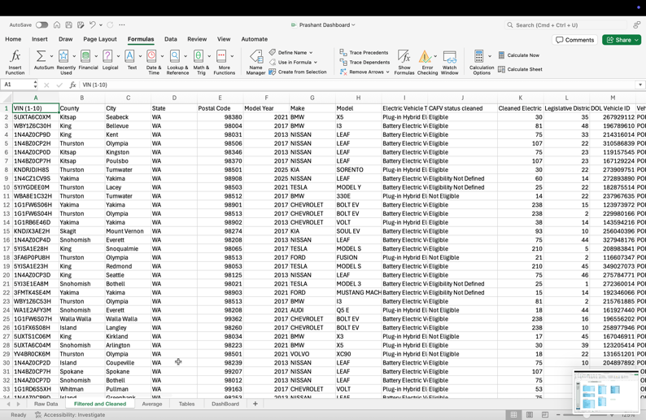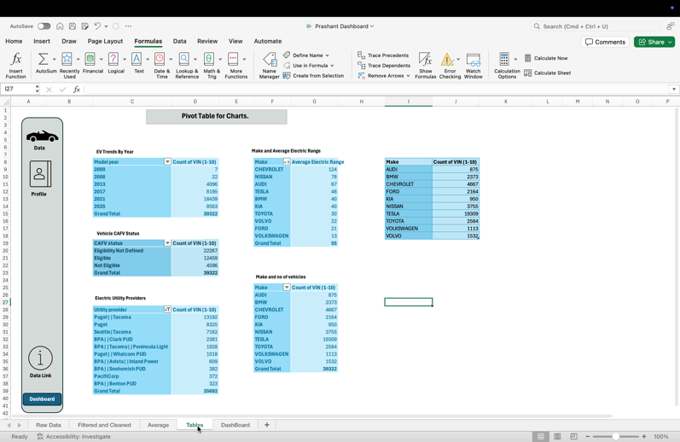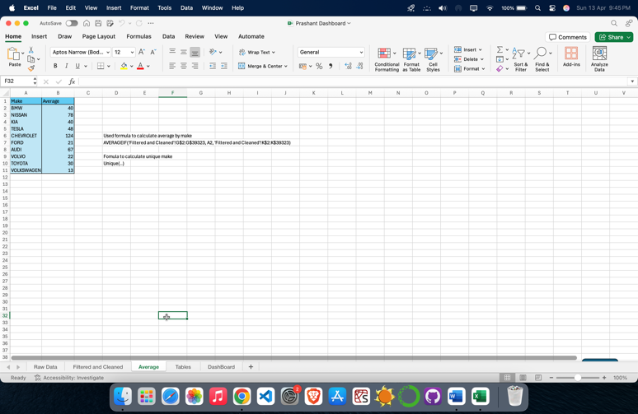

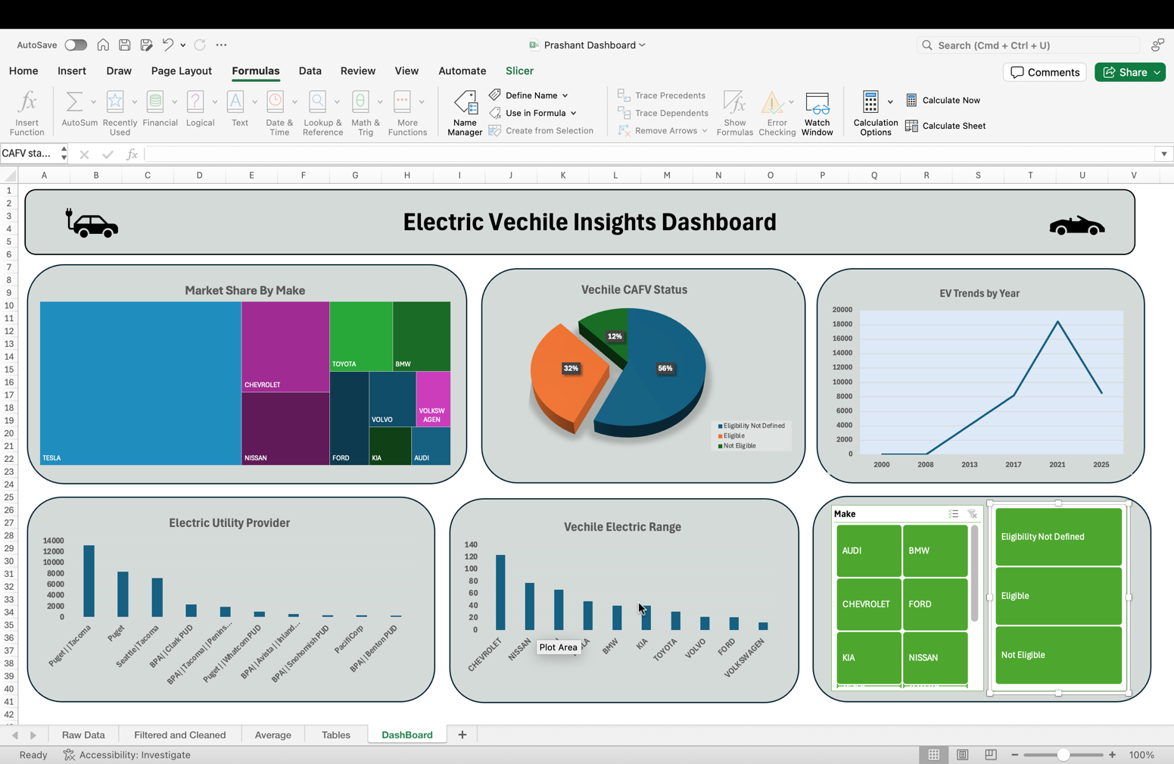

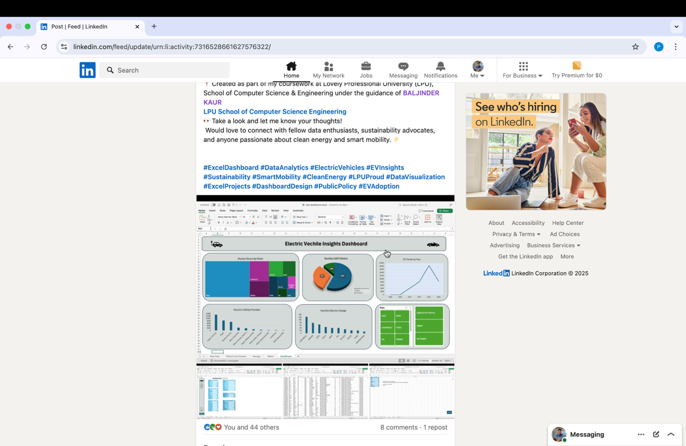

Linkedin link: https://www.linkedin.com/feed/update/urn:li:activity:7316528661627576322/